Performance Report

Model Evaluation Results
The performance of the proposed CNN-based deepfake audio detection system was evaluated using the held-out test dataset.

Overall Accuracy
The model achieved an overall classification accuracy of:
99.90%
This indicates that the system correctly classified almost all previously unseen audio recordings.

Equal Error Rate (EER)
The Equal Error Rate (EER) obtained on the test set was:
0.26%
A lower EER indicates better discrimination between genuine and deepfake audio samples. The obtained value demonstrates excellent detection capability.

Confusion Matrix
The confusion matrix obtained from the test set is shown below:
Actual / Predicted | Fake | Real
Fake | 1600 | 0
Real | 2 | 378
Confusion Matrix:
[[1600 0]
[ 2 378]]
The model correctly identified all fake audio samples and misclassified only two genuine recordings.

Classification Metrics
Class | Precision | Recall | F1-Score | Support
Fake | 1.00 | 1.00 | 1.00 | 1600
Real | 1.00 | 0.99 | 1.00 | 380

Macro Average
- Precision: 1.00
- Recall: 1.00
- F1-Score: 1.00

Weighted Average
- Precision: 1.00
- Recall: 1.00
- F1-Score: 1.00

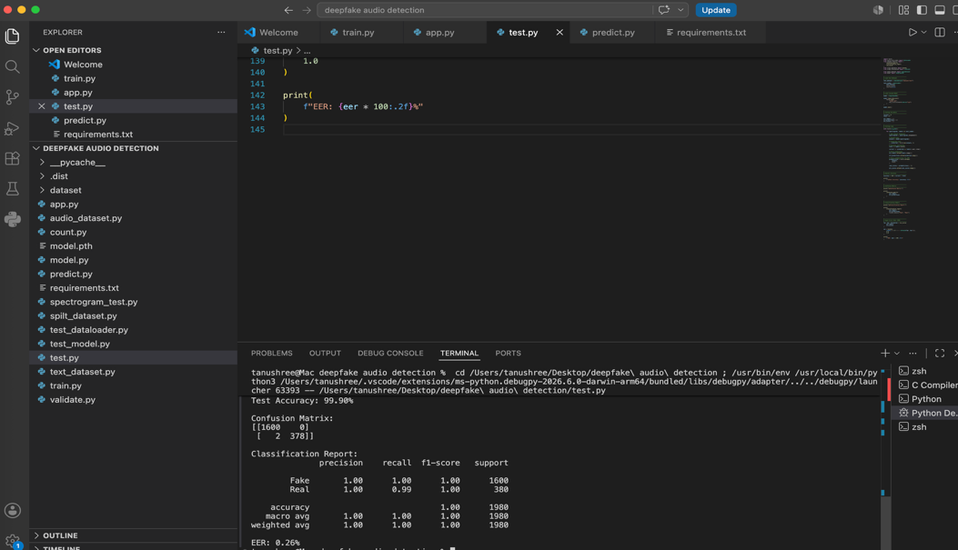

Conclusion
The proposed Mel-spectrogram-based Convolutional Neural Network demonstrated excellent performance in distinguishing genuine human speech from AI-generated deepfake audio. The model exceeded the required evaluation criteria of 80% accuracy and an EER below 12%, indicating strong generalization ability on previously unseen audio recordings.

